The Freed Hotel
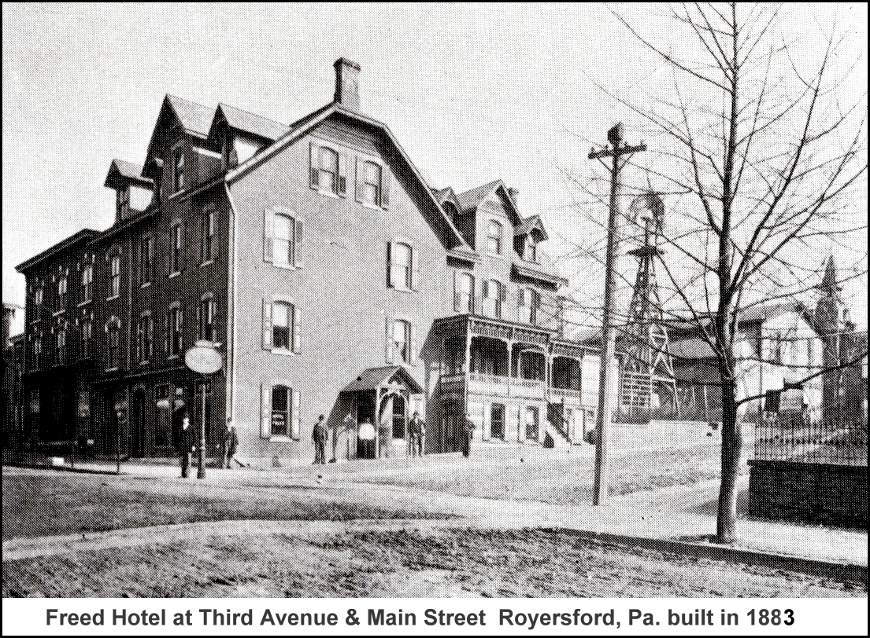
A. C. Freed built the Freed Hotel in 1893. His full name was Aaron Cassel Freed and he was born on March 17, 1848, the son of Michael and Sarah Cassel Freed. Aaron C. Freed, a native of Montgomery County, married Mary Binder in 1871. They moved to Royersford in the early 1870's and opened a shoemakers shop on the former site of the old Reading R. R. Station, now the Riverwalk Sales Office. He later moved into Frank St. Clair’s store on Main Street. He continued in shoemaking for about six years when he opened a restaurant. In 1893 he began construction of the Freed Hotel at the corner of Third Avenue and Main Street. He and his wife, Mary, conducted the business until June 1,1904. The Freeds had three children— Mrs. U. S. G. Finkbiner, of Royersford, John Freed, of Collegeville and Morris A. Freed of Royersford. It was his son Morris who took over the Hotel management in 1904. In a Pottstown newspaper story published in 1905, Morris is credited with the renovation and rebirth of the Freed Hotel into one of the finest establishments in the area. The hotel was centrally located at 3rd and Main Streets, just a short walk down to the railroad station.
There was a barbershop and cigar shop on the premises and at one period of time a funeral director worked out of the Freed Hotel. There was a full service livery and an icehouse and laundry located at the Freed Hotel. There were 3 other hotels in Royersford at this time, The American House, The Central Hotel and the Ciprey Steer. In 1928 the Freed Hotel was razed for the new bank building of the Royersford Trust Co. Today this structure is home to the Royersford Borough Hall.

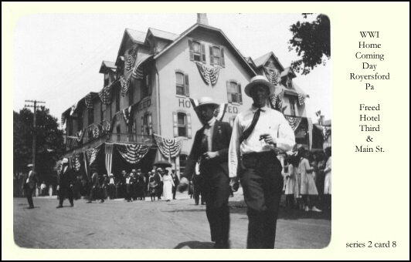
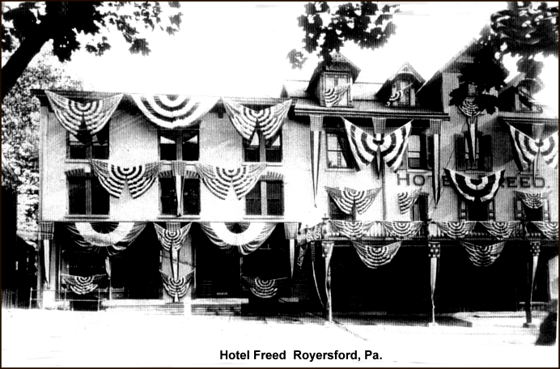
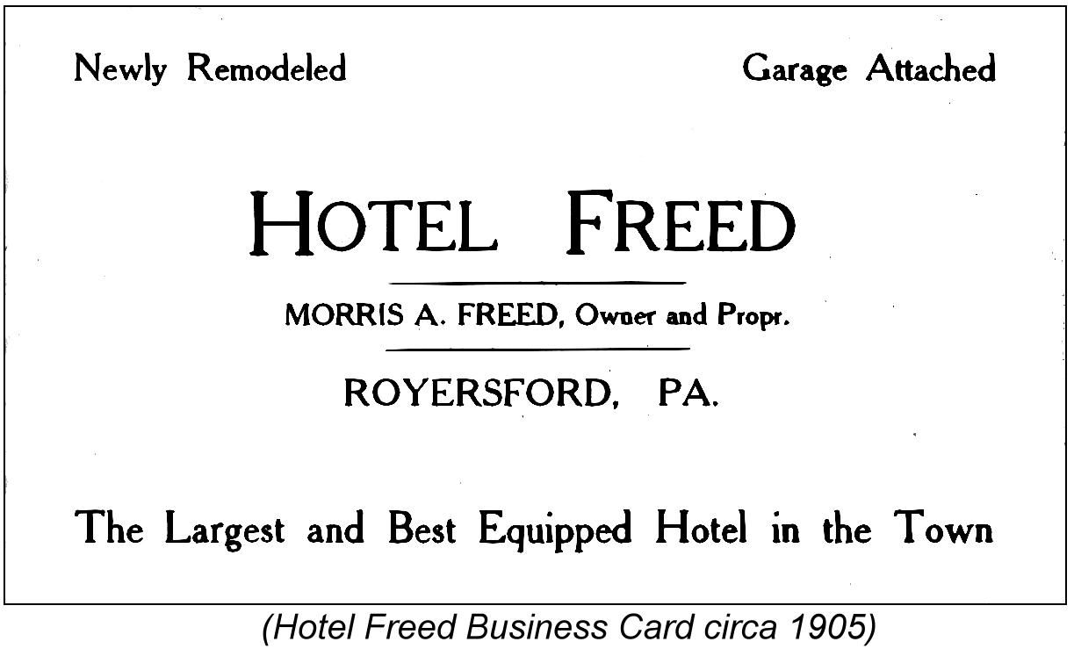
The following story appeared in a 1905 Pottstown newspaper “HOTEL FREED. MORRIS A. FREED PROPRIETOR” No feature is better calculated to create a favorable impression of a place than its hotel accommodations, and in the Hotel Freed Royersford can today boast of as well equipped public house as any in Montgomery County. Morris A. Freed succeeded his father, A. C. Freed, about a year ago, and has since made extensive improvements, building an addition, thereby adding several rooms; papered, refurnished

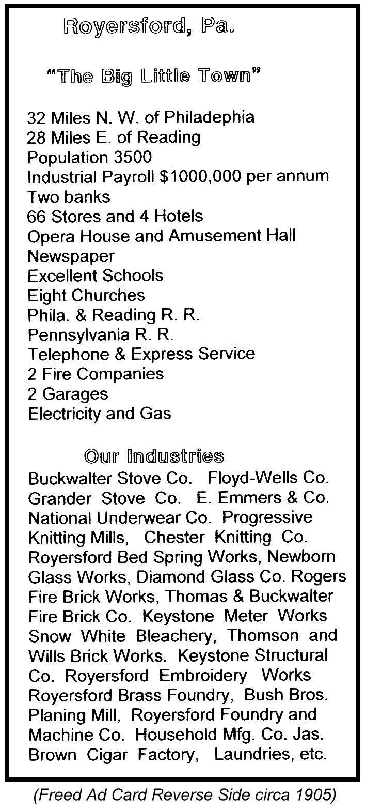
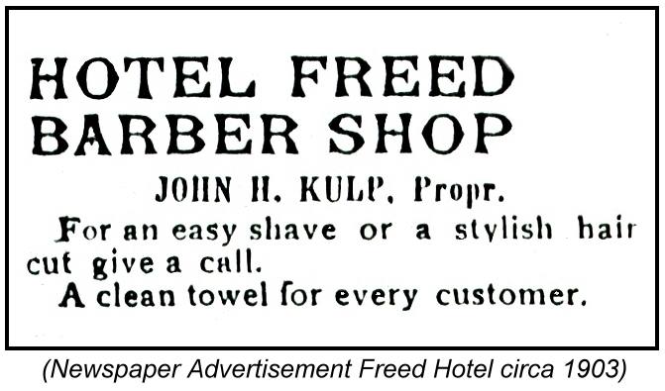
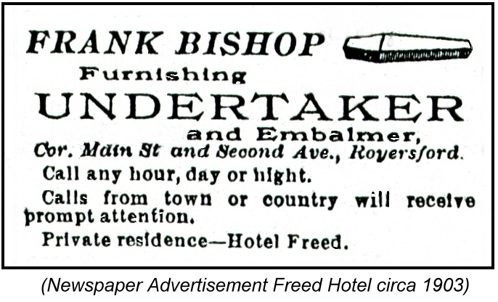
and renovated the place throughout, until now, with steam heat, gas and electric lights, baths and toilets, both ‘phones and other modern conveniences, the house is in a position to provide as good accommodations as any between Reading and Philadelphia. The house is most eligibly located in the very center of the business district and within two minutes walk of the railroad station. In connection is a well stocked bar, a well equipped livery, a steam laundry and a large ice house, Mr. Freed storing his own ice and having all laundry work done on premises. The property also includes two storerooms, which are rented as a barber shop and cigar store. The Hotel Freed is essentially the leading hotel of Royersford and is patronized liberally by commercial travelers and the theatrical profession. Mr. Freed may be the youngest hotel proprietor in the Schuylkill Valley. He enjoys a wide acquaintance throughout this section, and having practically grown up in the business, is thoroughly capable to conduct it. Since he took charge he has largely increased the popularity of the house and has been particularly successful.

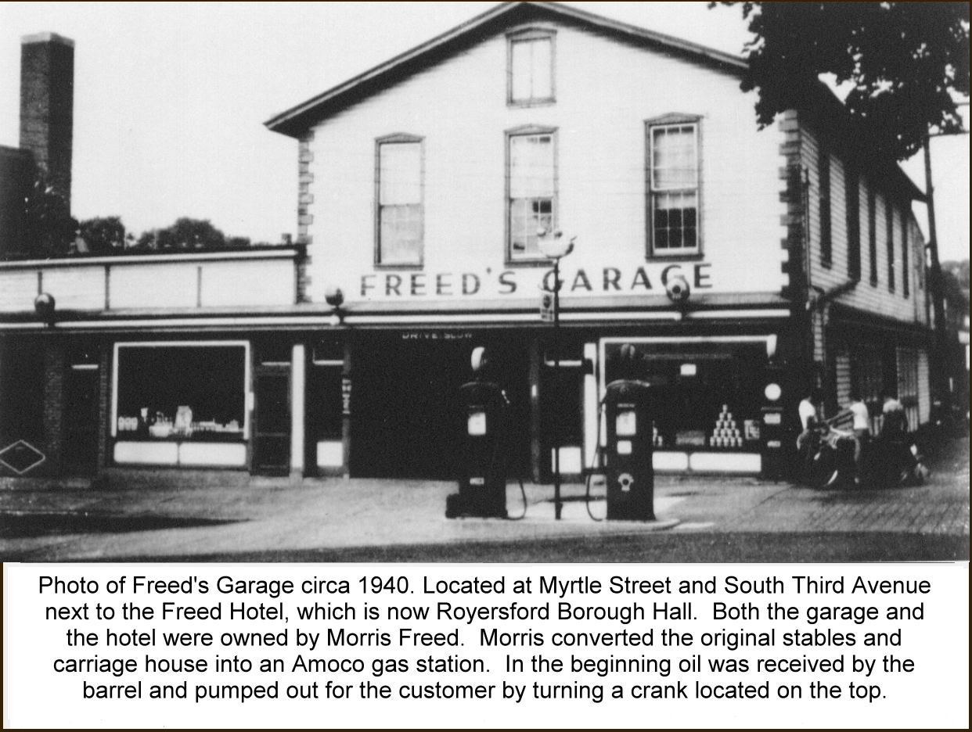
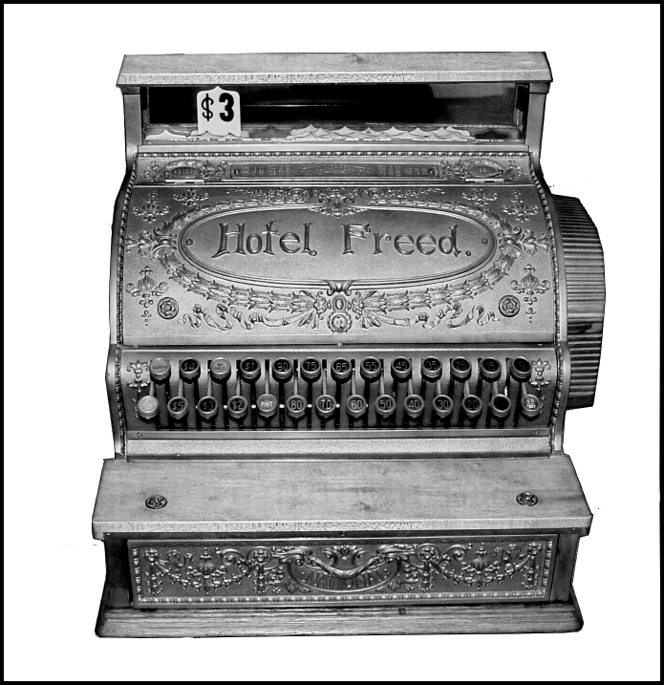
Pictured here to the left is the original Hotel Freed cash register and my inspiration to do this newsletter story. This beautiful piece came to the museum from Richard Obenshine. Dick, who past away last year, was a loyal member of the society and a friend of mine. I have fond memories of the Sunday afternoons spent at the old museum listening to the stories that Dick, Elmer and Lawrence shared with me. I guess I’m the one who is sharing the stories now and I hope I can do half as good as my friends once did.

by William C. Brunner

Spring-Ford Area Historical Society Newsletter Insert for January 2006

